Course Code: CSA1557

Course Name: Cloud Computing and Big Data Analytics

R.Pranusha

192111023

9) Create a simple cloud software application for Hospital information system for SIMATS Hospital using any Cloud Service Provider to demonstrate SaaS with fields of patient name, age, address, phone, email, Attender name, attender phone, doctor name, diseases, etc.

AIM: To Create a simple cloud software application for Hospital information system for SIMATS Hospital using any Cloud Service Provider to demonstrate SaaS

PROCEDURE:

step1: Go to zoho.com.

step 2: Log into the zoho.com.

step 3: Select one application step.

step4: Enter application name as library book reservation system.

step 5: Created new application as library book reservation system.

step 6: Select one form

step 7: The software has been created.

IMPLEMENTATION:

STEP1: GOTO ZOHO.COM

STEP 2: LOGIN TO THE ZOHO.COM

STEP 3: SELECT ONE APPLICATION

STEP 4: ENTER APPLICATION NAME

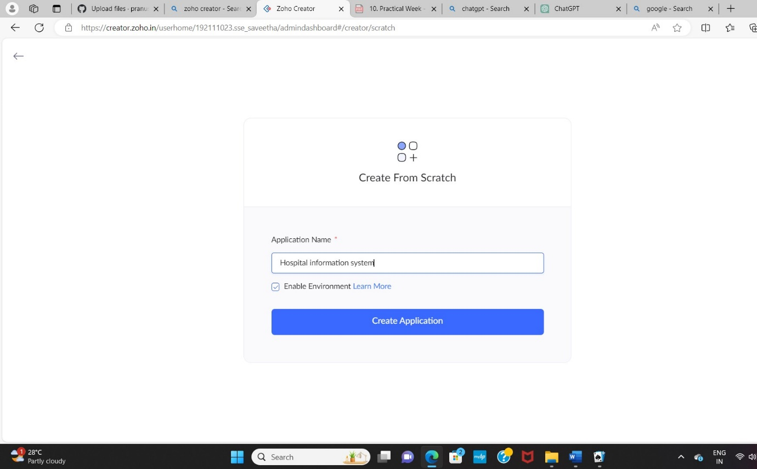

STEP 5: CREATED NEW APPLICATION

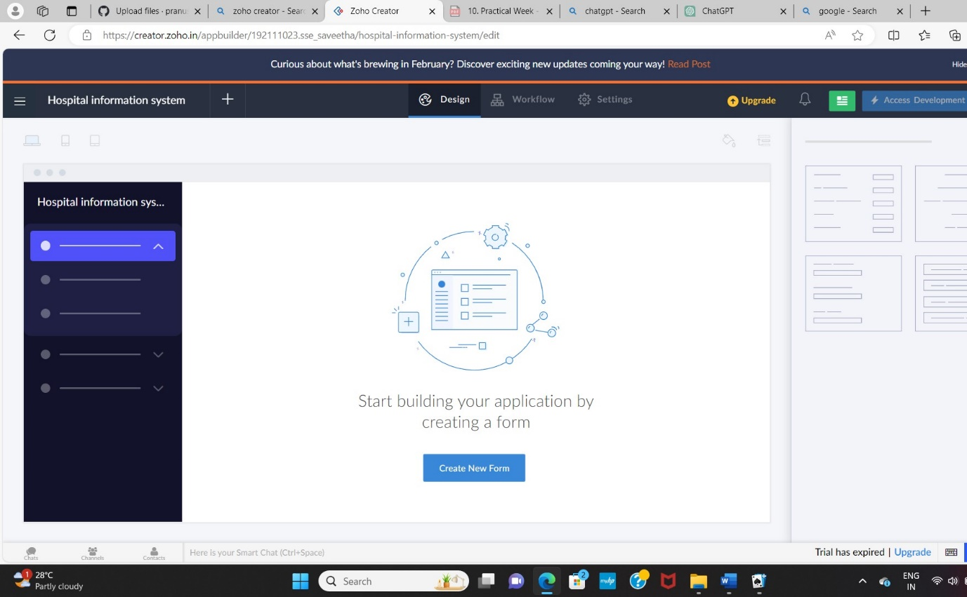

STEP 6: Select from Stratch and Create form as login.

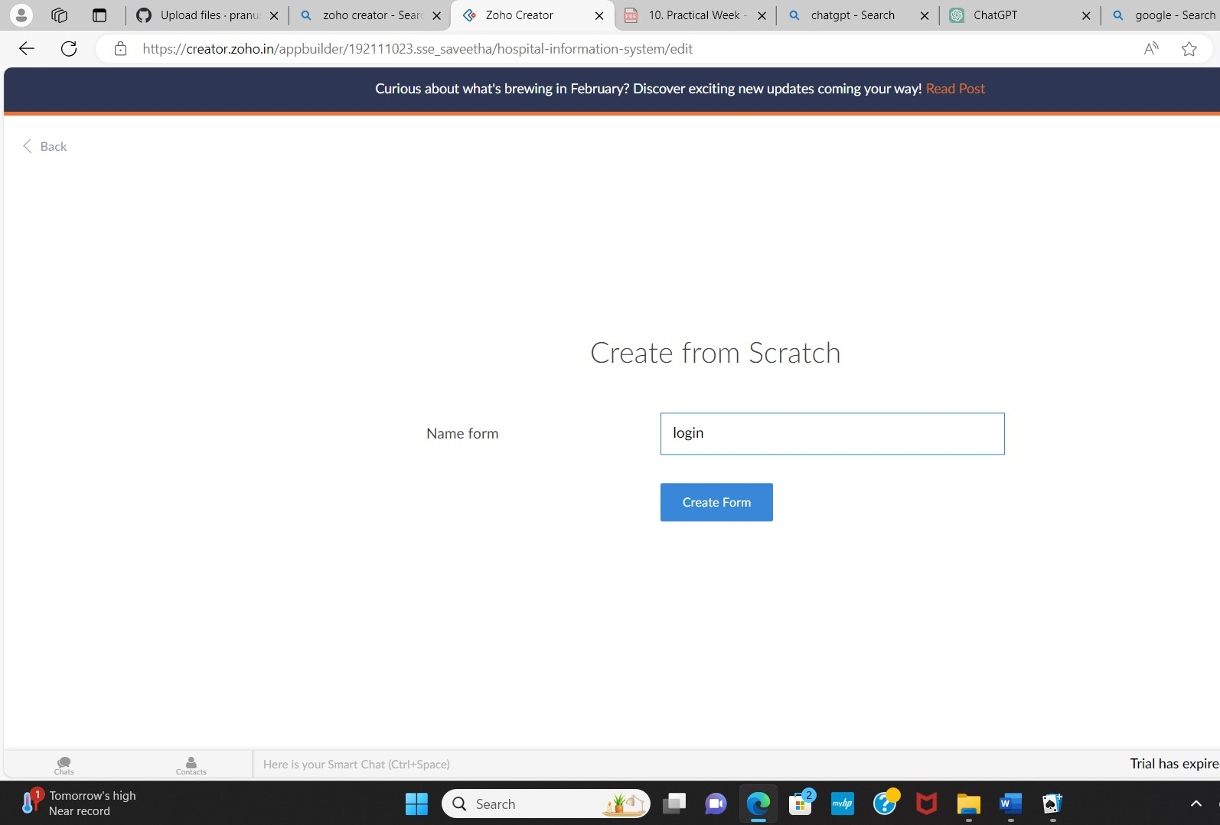

STEP 7: The form has been created as login.

Choose the fields.

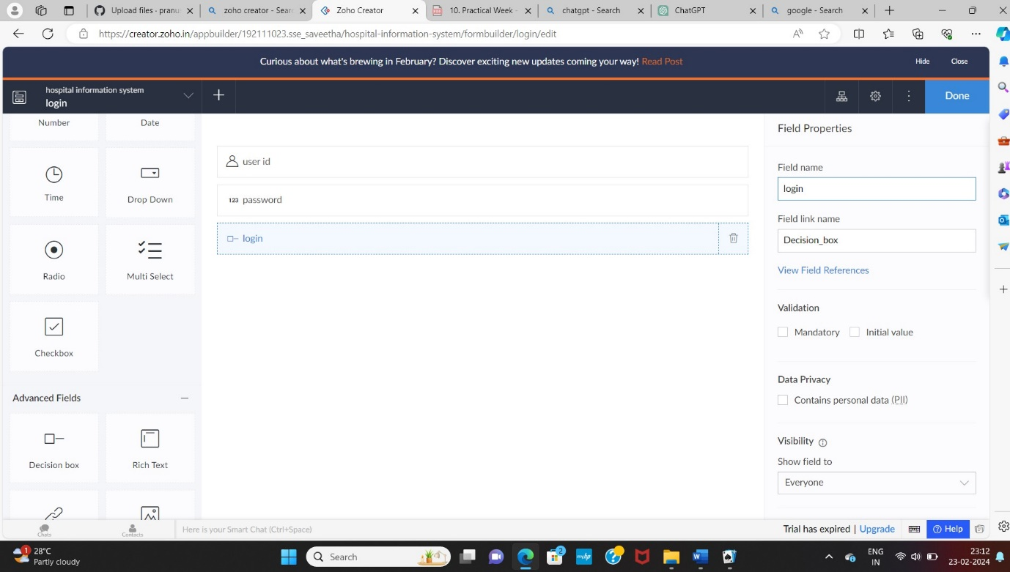

STEP 8: Click Access Development Live and enter the details to access.

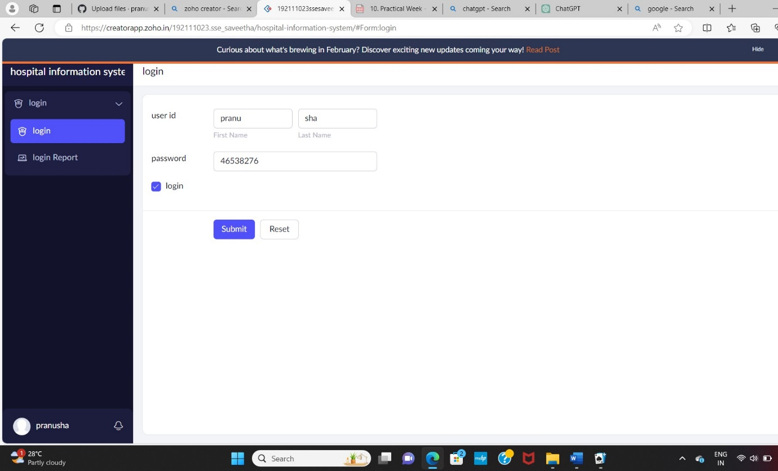

STEP 9: The report has been registered in the login report.

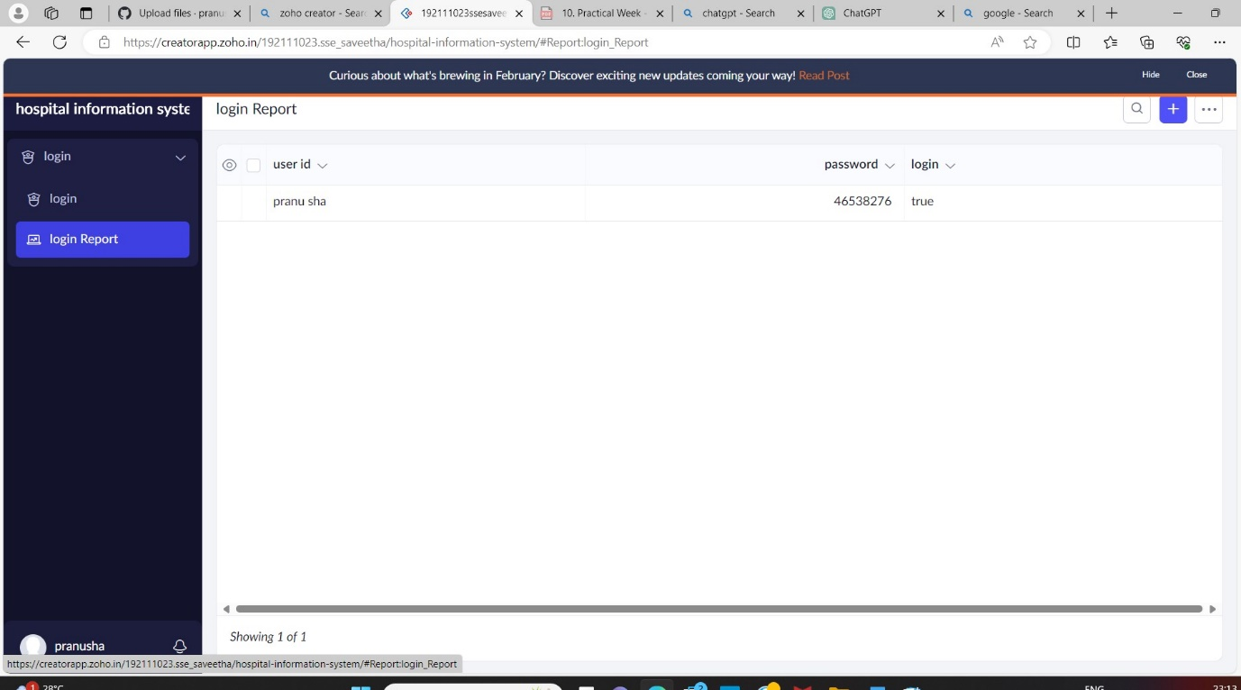

STEP 10: Select from Stratch and Create form as apollo hospitals.

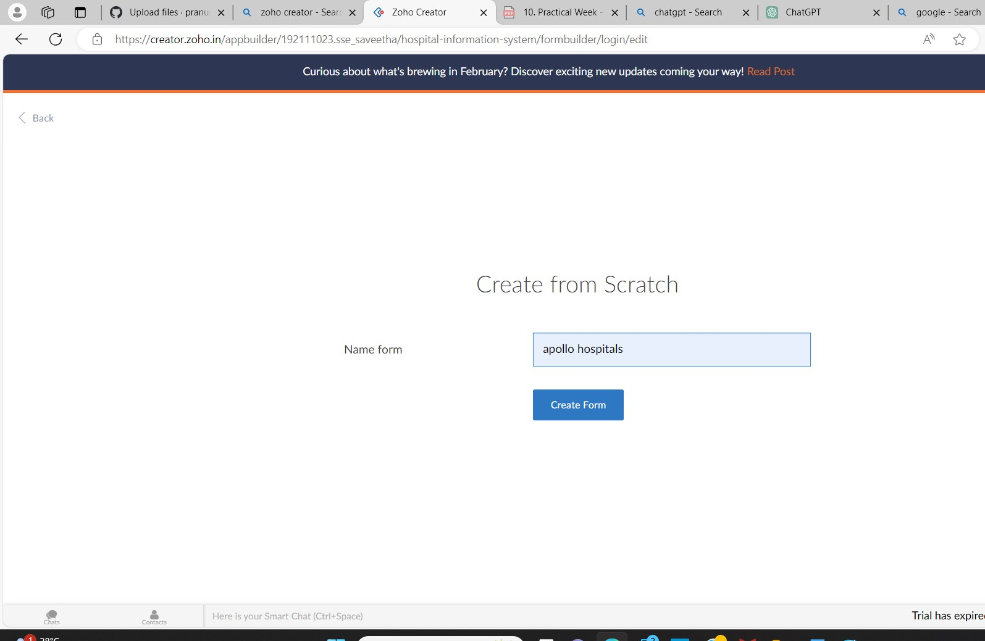

STEP 11: The form has been created as apollo hospitals.

Choose the fields.

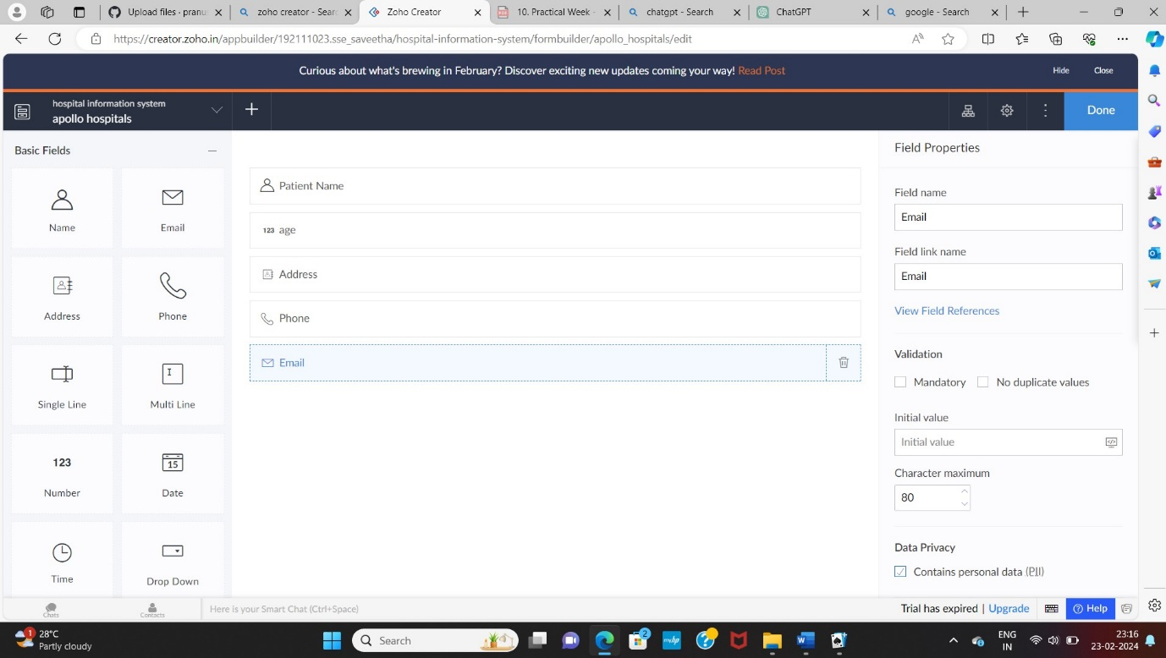

STEP 12: Click Access Development Live and enter the details to access.

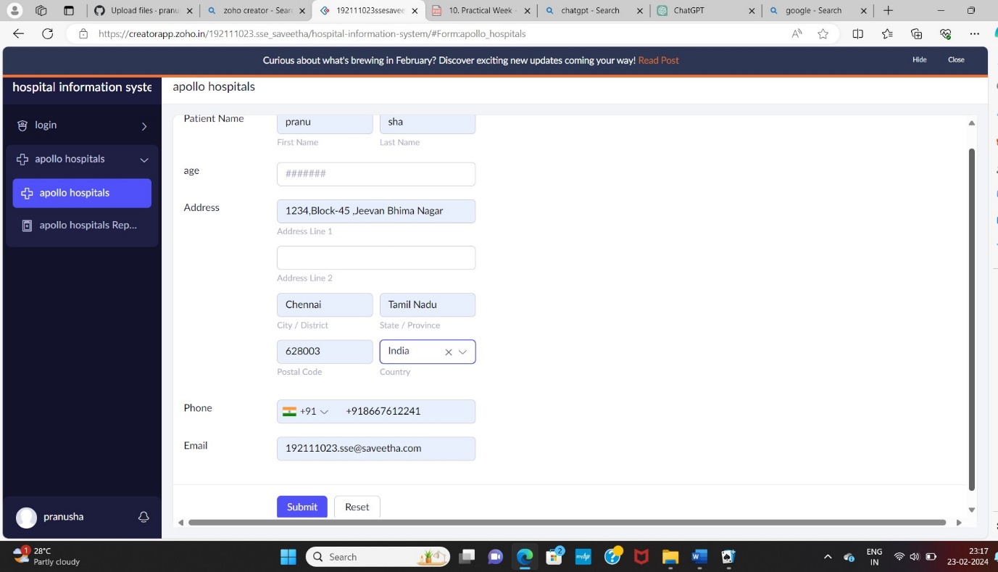

STEP 13: The report has been registered in the apollo hospital report.

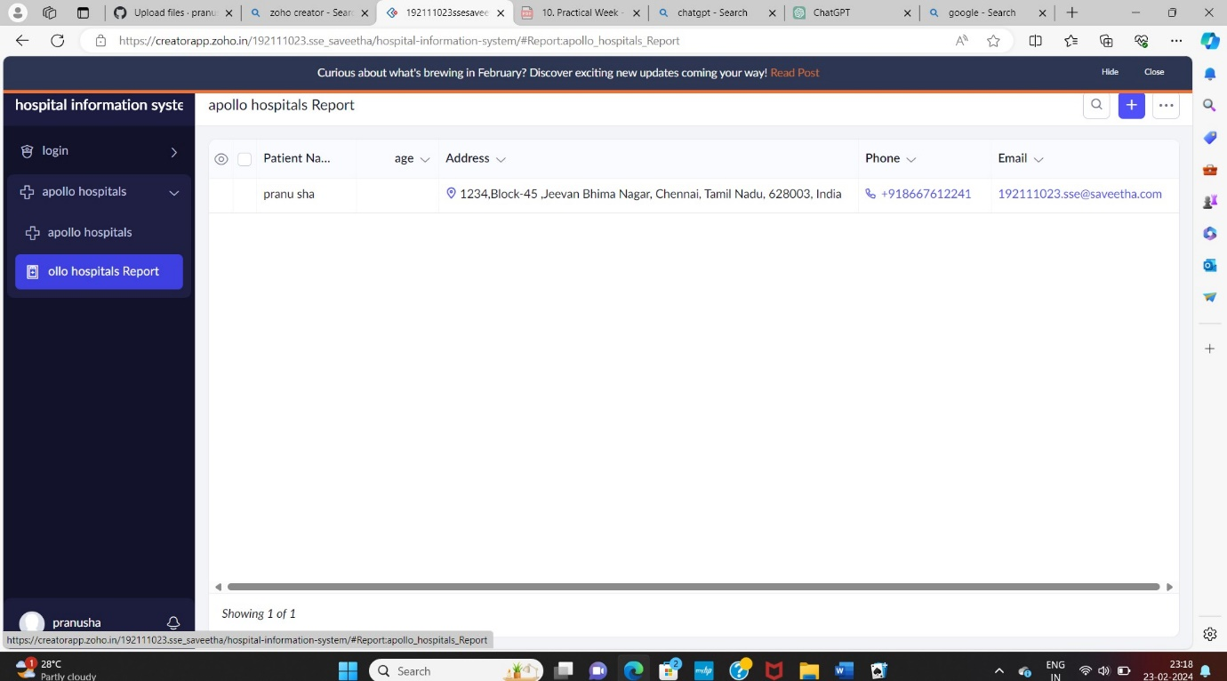

STEP 14: Select from Stratch and Create form as attender form.

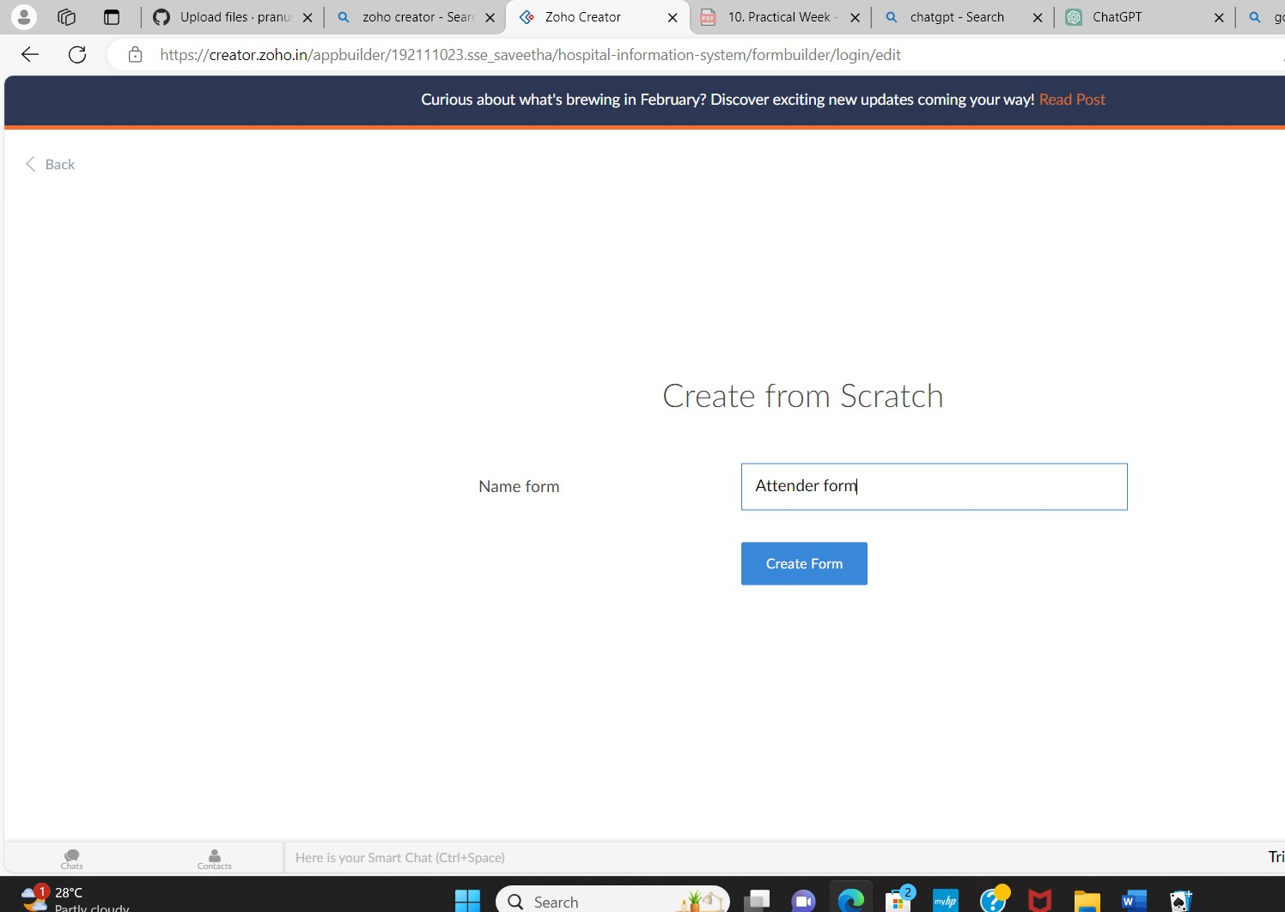

STEP 15: The form has been created as attender form.

Choose the fields.

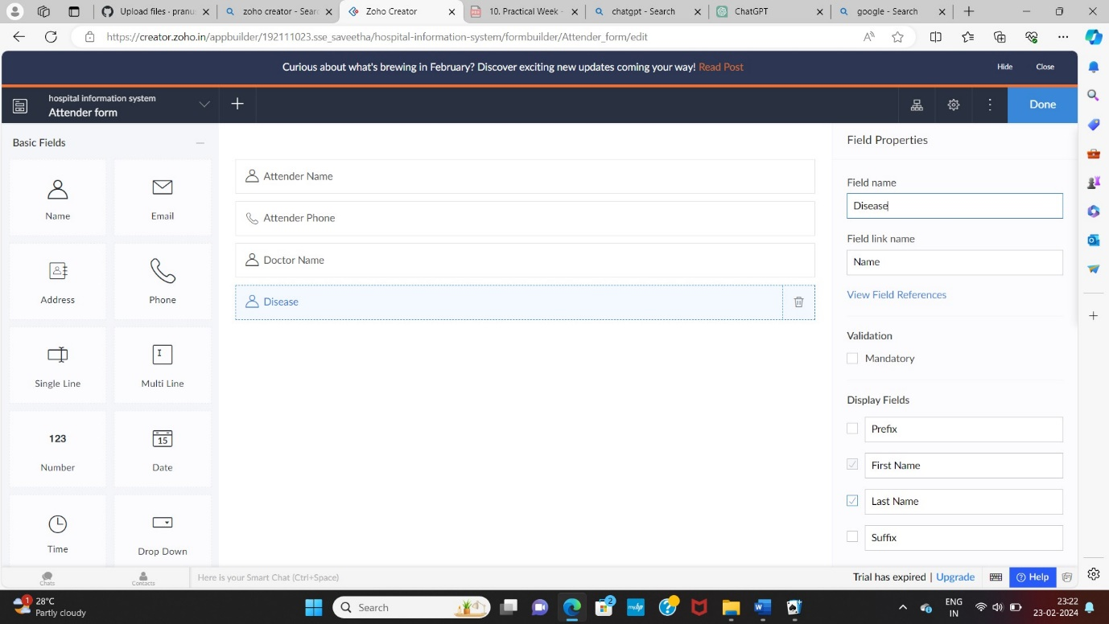

STEP 16: Click Access Development Live and enter the details to access.

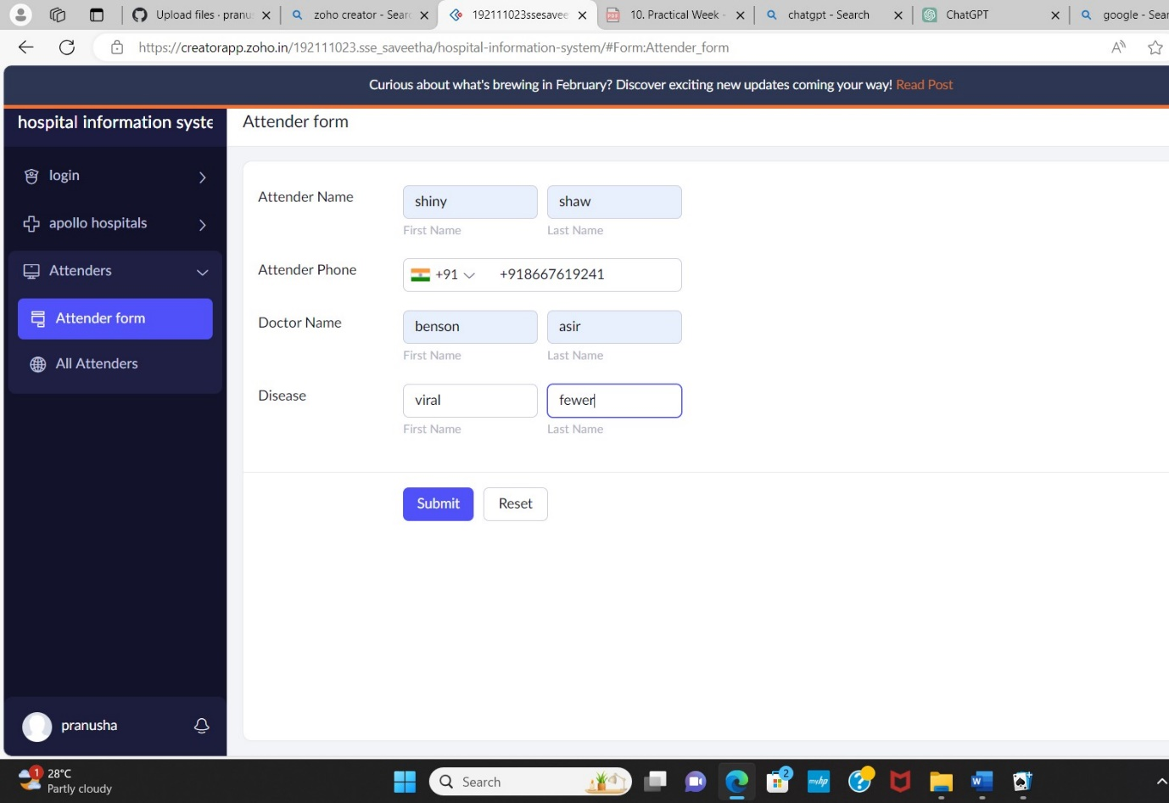

STEP 17: The report has been registered in the attender form report.

